Targeting Multiple
FPGA Development Boards
Design Description Document
By Iain Waugh

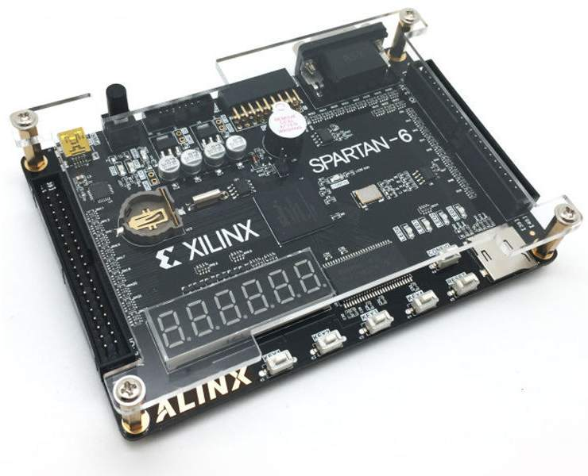

Table of Contents
1 System Overview 3
1.1 FPGA 3
1.2 Clocks 3
1.3 SDRAM 3
1.3.1 Estimated Bandwidth 3
1.4 Camera Interface 4
1.5 VGA Out 4
1.5.1 Video Timings 4
1.5.2 Non-Frame-Buffered Video Modes 5
1.5.3 Possible Uses of Non-Frame-Buffered Video Modes 5
1.5.4 Frame-Buffered Video Modes 5
1.6 Real-Time Clock 6
1.7 EEPROM 7
1.8 Micro SD Card 7
1.9 Hex 7-Segment Display 7
1.10 USB UART 7
1.11 Buttons 7
2 Design Notes 8
2.1 VGA Output 8
3 Testing 9
3.1 VGA Output 9

Overview
This project started off only targeting the AX309 development board and the intention was to use that board as a platform to write experimental code for a custom computing system. One of the key outputs of such a system is to a computer monitor, so VGA is a natural choice to get meaningful output to the user. Another useful output is a serial port.
After getting a basic test pattern out on the AX309, I took a look at the stack of development boards I had lying around and wondered what it would take to write a core block of code that would run on all of them.
So, a bit more coding later and we have the ability to target more than 1 board and the beginnings of targeting more than 1 FPGA vendor (Xilinx and Altera/Intel).

Project File Hierarchy
doc – Project documents
src – Synthesisable VHDL source code
sim – Testbenches (not synthesised)
syn – makefiles, scripts and design constraints for the platforms

Multi-Platform System Architecture
To build an FPGA image for any board, make sure you’ve got the appropriate build executables on your PATH (make, vivado, ise, quartus_*), open a terminal in the appropriate build directory and type “make synth” to get a synthesised netlist, or “make” to go all the way to an FPGA bitstream.
Example:
cd syn/zedboard
make

AX309 Board Overview

FPGA
The FPGA on this board is a Xilinx XC6SLX9-2FTG256.

The “-2” speed grade part’s BlockRAM can operate up to 280MHz and the DSPs can operate up to 333MHz (but it’s likely to be a challenge getting your design up that high, even with all register stages turned on).

Clocks
The board has a single 50MHz clock module.

The XC6SLX9 FPGA has 2x PLLs and 4x DLLs.

SDRAM
The board is fitted with one H57V256GTR-75C chip with 16 data bits.
This is a 133MHz SDR SDRAM.

It’s the fastest clock on the board (apart from some possible VGA modes).

The Xilinx MIG tool does not generate SDR IP cores, so this needs to be written from scratch.

Estimated Bandwidth
We have 133MHz x 16 bits for input and output, multiplied by some factor for the read/write efficiency. It’s too early to set a figure for how efficient the read/write cycles will be because that’s up to how well the controller is written. We can make an initial guess of ~75%, gives ~100Mbit/sec to cover all reads and writes.

Camera Interface
Compatible cameras are:
- OV7670
- OV2640
- Other camera modules with similar interfaces

(TODO: Write a simple description of the interface)

VGA Out
One of the main attractions of this board is that it has a VGA output port.
This is a standard 25-pin VGA connector. The digital outputs from the FPGA pass through a resistor network to get an analog value. Red has 5 bits, Green has 6 bits and Blue has 5 bits.

We generate standard video modes by controlling the VGA_HSYNC and VGA_VSYNC signals.

Unfortunately, the monitor’s EDID pins are not connected, so we can’t interrogate the monitor’s display capabilities. Take a guess with some popular mode options.

Video Timings
Some non-obvious points from http://www.epanorama.net/faq/vga2rgb/calc.html
The horizontal timing parameters must normally be multiple of 8 because this is the resolution which standard VGA cards operate in. Those timings and same applies to most of SVGA cards also.

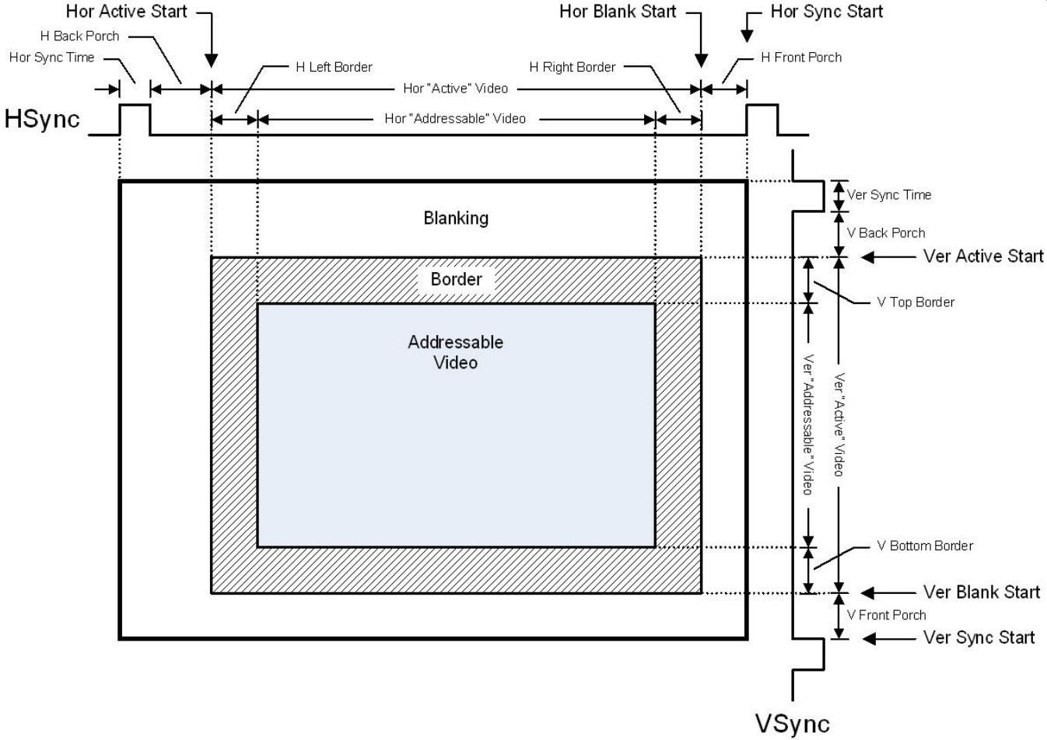

Non-Frame-Buffered Video Modes
If we don’t use an SDRAM pixel store and we generate video on the fly, we can set the pixel clock as high as we want.
2560x1600 at 60fps is not out of the question at a pixel frequency of 348.50MHz. Signal integrity and pixel clock jitter will be quite pronounced, however.

Possible Uses of Non-Frame-Buffered Video Modes
Video up-scaling algorithms.
Real-time camera output (for 2k+ horizontal pixels).

Frame-Buffered Video Modes
Frame buffered video modes are limited by the SDRAM I/O speed, previously estimated at 100Mbit/sec. 16 bits per RGB pixel gives us a max pixel rate of 50MHz. We can double that rate by using 8 bits per RGB pixel and packing 2 pixels/word into the RAM.

Suggested VESA standard video modes:

X | Y | Aspect Ratio | Refresh  (Hz) | VESA Standard  Pixel Rate  (MHz)
640 | 400 | 8:5 | 85 | 31.50
640 | 480 (NTSC) | 4:3 | 60 | 25.175
854 | 480 | 16:9
768 | 576 (PAL) | 4:3
1024 | 576 | 16:9
800 | 600 | 4:3 | 60 | 40.00
800 | 600 | 4:3 | 72 | 50.00
1024 | 600 | 16:9
1024 | 768 | 4:3 | 60 | 65.00
1024 | 768 | 4:3 | 70 | 75.00
1280 | 768 | 5:3 | 60 | 79.50
1280 | 768 | 5:3 | 75 | 102.25
1360 | 768 | 16:9-ish | 60 | 85.5
1600 | 900 | 16:9
1920 | 1080 | 16:9
1920 | 1200 | 8:5 | 60 | 193.25

The aspect ratios are an interesting problem because most people have 16:9 monitors these days. We suggest adding run-time support for 4:3 modes on 16:9 monitors by having a 4:3 addressable range and padding the sides with black (or near-black to let the monitor auto-adjust) to reach 16:9.

Real-Time Clock
There is a coin cell holder on the board. You can get the real time and date if you like. Otherwise, this can be used to count seconds that have passed since power-on.

EEPROM
There are 2 flash devices on the board:
- One is the SPI flash which is used to program bitfiles into the FPGA; we won’t be writing about that one here.
- The other is an 24LC04 I2C EEPROM, with 4KBytes of storage.

Micro SD Card
You can read and write to standard Micro SD cards.

Note: The board layout appears to be wrong. It looks like the chip-select line is tied high all the time and that one of the data lines is connected to the wrong FPGA pin. No problem, but I’m surprised that the original reference design didn’t run into this trouble.

Hex 7-Segment Display
No datasheet. We will have to reverse-engineer the Verilog driver source code to figure out how to drive it. First impressions look like it uses a row/column scanning method.

USB UART
This is a Silicon Labs CP2102 chip that converts USB data to RS232 protocol at LVTTL signalling levels, up to 1Mbps.

Buttons
There are 4 keys and a button labelled “Reset” which are inputs to the board. The “Reset” button is just another I/O (there’s nothing special about it), so it can be anything you want.

The CONFIG button is not available for user use; it initiates a re-programming cycle from the SPI flash chip.

Design Notes

VGA Output
Synthesis-time generics:
- Input clock period
- Buffered or un-buffered input (for SDRAM sources or direct logic input sources)
- Max X resolution (for X counter width and line buffer depth)
- Max Y resolution (for Y counter width)
- Switchable with Modelines or using fixed size

Run-time requirements:
- Take pixel data in and drive it onto a monitor.
- Switchable between 4:3 and 16:9 aspect ratio monitors (default to 16:9).
- Video modes and frame rates defined.
- Optional: More than 1 clock input?
- 8 or 16-bit pixel data:
- 2:3:2 = 8-bit RGB
- 5:6:5 = 16-bit RGB
- AXI stream data input

No fancy processing at this stage; just output. If you want video overlays or other processing, do it before this module.

Having more than 1 clock input could be an interesting way to offer different modes, but we’re getting into some very difficult reconfiguration problems here.

Testing

VGA Output
Q: What FPGA IO drive strength and slew rate gives the best VGA quality? i.e. How do we avoid accidentally having ghosting and blurry edges?
A: We need to measure the signal quality to find out.

- Synthesise several FPGA images with different combinations of drive strength and slew rate.
- Use an oscilloscope to measure the signal (at a fake DB25 connector with a 50 Ohm load from R, G and B to GND.
- Record the waveforms below.

